
19th Annual Conference on the Americas

sponsored by

The Americas Council
University System of Georgia
&
Georgia College
Armstrong State University
Georgia State University Perimeter College
Kennesaw State University
University of North Georgia

Hosted and sponsored by

Georgia College
Department of Modern Languages & Cultures, Department of History and Geography, Latin American & Caribbean Studies, The Old Governor’s Mansion and College of Arts & Sciences
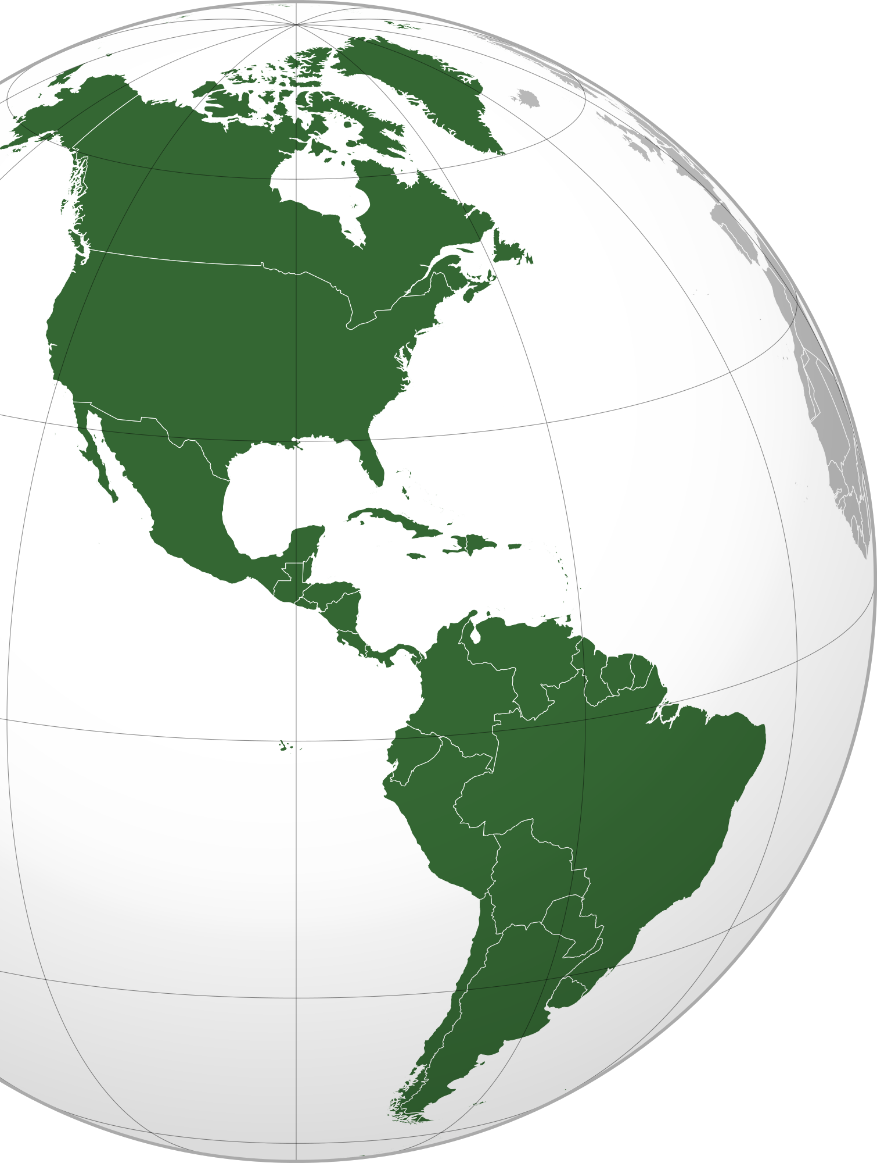
February 5th- 6th 2016

All sessions will be held in Atkinson Hall on Main Campus
Lunch and Keynote Address: MSU Banquet Room
The 19th Annual Conference on the Americas

Friday, February 5

1:00 – 1:45 pm Registration

1:45 – 3:00 pm Session 1A Room A
.
Moderator: Dr. Mariana Stoyanova, Georgia College & State University

Michael Lerzo, Georgia College & State University, “Examining Service Learning Opportunities in Spanish Classes”

This presentation analyzes the experiences of participants in a Service Learning program implemented at Georgia College. Upper level Spanish students assist professors in lower level Spanish classes both in hybrid and traditional settings for class credit. This position is also compared to the experiences of a Supplemental Instructor. Challenges are analyzed as well as plans for improvement and suggestions for expansion. Finally, conclusions will be made regarding the impact and benefits of the program.

Caitlin Murray, Georgia College & State University, “Pedagogical Trends and Theories in Teaching Spanish as a Second Language”

The presentation explores and contrasts firsthand experiences with current pedagogical trends and theories in teaching Spanish as a second language, with emphasis on grammar concepts, to beginner level adults with L1 English in a city library in small southern town. The class was taught twice a week for eleven weeks in the fall of 2015 as part of community enrichment program aimed to offer in demand foreign languages free of charge to the community.

Sarah David, Georgia College & State University, “Teaching Conversational Spanish”

This presentation is about a service learning project, which focused on teaching basic, conversational Spanish at Mary Vinson Public Library in Milledgeville, Georgia for six weeks during the summer of 2015. The aim of the presentation is to explore the differences between language pedagogy theories and practice in second language acquisition, focusing specifically on beginner adults with L1 English who are learning Spanish as part of a community enrichment program.

Marta Galindo, Georgia College & State University, “La Pronunciación y Grafía de los Fonemas /b/ y /v/ en España y Algunas áreas de América Latina.

Este trabajo explora la pronunciación y grafía de los fonemas /b/ y /v/ en España y algunas áreas de América Latina. Para su desarrollo, se ha considerado: datos históricos, geográficos y sociales, bajo las perspectivas de lingüistas, humanistas, e intelectuales que han contribuido al enriquecimiento y expansión de la lengua.
1:45 - 3:00 pm Session 1B Room B

Moderator: Brantley Nicholson, Georgia College & State University
Dr. Kristie Hislope, University of North Georgia, “Assessing Latin American Cultures in Beginning Spanish Language Courses”
In this paper I discuss how UNG’s Spanish 1001 courses measure our Area B outcome: “Students will analyze political, cultural, or socioeconomic interactions among people of the world.” Our measurement instrument is a composition in which students invent an alternate identity for the witness protection program, choose a Spanish-speaking country to move to, and research that country mapping their information to our outcome. Students’ perceptions on Latin American culture and the project are discussed.

Kayla Abercrombie, Georgia College &State University, “The Challenges and Benefits of teaching Spanish at an Undergraduate Level”

In foreign language education at the undergraduate level there are many aspects to consider that affect the performance of the students and the effectiveness of the instructors. One of the most authoritative characteristics in affecting these conditions is the pace that courses are taught at and the amount of material taught. From the perspectives of instructors and students, this paper seeks to understand the benefits and drawbacks of teaching Spanish with its current structure and pace.

Dr. Lynn Fedeli and Dr. Bill Griffin, Kennesaw State University, “How do FL graduates actually use their FL in the workplace? A data-based response”

Teachers and advisors have offered many reasons for pursuing a degree in foreign languages (FL), often reinforced only anecdotally. To develop data revealing how graduates actually use their FL in the workplace, the researchers developed an online survey sent out to all KSU graduates between 1996-2015. In their presentation, they will share contents of the survey including why some questions were asked and not others, reporting both the quantitative and qualitative results of their work.

1:45 - 3:00 pm Session 1C Room C

Moderator: Dr. Álvaro Torres-Calderón, University of North Georgia

Dr. Louis Bourne, Georgia College & State University, “Corrupción urbana, corrupción revolucionaria: el banquero”

Federico Robles de "La región más transparente" (1958) y el rico veterano protagonista de "La muerte de Artemio Cruz" (1962), dos hitos en la novelística del mexicano Carlos Fuentes. Este ensayo pretende comparar y contrastar las figuras de dos hombres ambiciosos cuya búsqueda del poder, la riqueza y la influencia representan dos ejemplos de la corrupción que pervive en la sociedad mexicana ayer y hoy.

Joseph Floyd, Georgia State University, Perimeter College, “La Sombra del Banano (The Shadow the Banana): Racism and Nationalism in Costa Rica, 1925-1935”

My paper, "La Sombra del Banano (The Shadow the Banana): Racism and Nationalism in Costa Rica, 1925-1935" examines opposition to the United Fruit Co., and restrictions on the immigration and migration of black West Indians. It describes how Costa Rican intellectuals and politicians utilized Anglo-American ideas of white supremacy and appealed to shared interests of the U.S. and Costa Rica as white nations facing a "Negro problem."

3:00 – 3:15 Coffee Break

3:15– 4:15 pm Panel Discussion
Dr. Gary Van Valen’s book “Indigenous Agency in the Amazon: The Mojos in Liberal and Rubber-Boom Bolivia, 1842-1932.”

Panel Members: Dr. Gary Van Valen, University of West Georgia, Dr. José de Arimatéia da Cruz, Armstrong State University, Dr. George Danns, University of North Georgia, Mr. Ernie Guyton, Georgia State University, Perimeter College, & Stephanie Opperman, Georgia College & State University

Sponsored by the Georgia College Department of History, Dr. Aran MacKinnon and Latin American & Caribbean Studies, Dr. Stephanie Opperman

6:00pm – Reception at the Old Governor’s Mansion (Education Building) followed by a private tour of the Mansion.
Courtesy of Matthew Davis and his Team

Saturday, February 6
8:30 – 9:00 am Registration

9:00 – 10:15 am Session 2A Room A

Moderator: Mr, Ernie Guyton, Georgia State University Perimeter College

Dr. Erica Johnson, Gordon State College, "Enlightened Correspondence with Thomas Jefferson during Haitian Revolution"

U.S. President Thomas Jefferson corresponded with intellectuals in French Saint-Domingue during the Haitian Revolution. While scholars acknowledge the commercial relationship between the U.S. and Haiti, they tend to overlook the learned exchanges between Jefferson and Saint-Dominguans. My paper explores the efforts of learned peoples on both sides of the Haitian Revolution to engage President Jefferson in enlightened correspondence regarding medicine and agriculture while also expressing their sentiments regarding events in revolutionary Saint-Domingue in the late eighteenth century.

Sofia Papa, Georgia College & State University, “Simon Bolivar: The Liberator”

Simon Bolivar, The Liberator, established the foundation for the dream of a strong, united, and independent Latin America. However, the state of the New World today is more complicated than ever before. It is often said that time fixes everything, but after two centuries since the time of Bolivar and with the many challenges that still persist in Latin America today, perhaps time has converted the Liberator's dream into a nightmare.

Dr. José de Arimateia da Cruz, Armstrong State University, “Guyana-Venezuela: A Conflict Like no Other.”
While the rest of the world is concerned about the refugee crisis in Europe, the conflict in Syria, and the potential contenders in the U.S. presidential elections of 2016, there is a brewing dispute between Guyana and Venezuela in Latin America. As a result of this diverted attention, there are few reports regarding the instability of an already fragile region. The dispute between the two nations centers on the lands west of the Essequibo River of Guyana. This presentation examines the root cause(s) of this conflict and what it means to the national security of the Americas.

Dr. José de Arimateia da Cruz, James Madison Marye, and Taylor Alvarez, Armstrong State University, "Transnational Organized Crime in Latin America: An Insidious National Security Threat”

In the globalized world of the twenty-first, crime has become an epidemic. It not only destroys the social fabric of society but also corrupts governments, governmental officials, politicians, etc. In this presentation we will discuss the evolution of gangs from 1st generation to 3rd generation and examine the national security implications of the rise of globalized gangs, especially within the context of Latin America.
9:00 – 10:15 am Session 2B Room B
Moderator: Dr. Lynn Fedeli, Kennesaw State University

Bethany Bateman, University of Georgia, “Runasimita yachasunchis: Best practices in Quechua language education”

Spoken in Peru, Bolivia, Ecuador, and small regions in Argentina, Colombia, and Chile, Quechua (or Kichwa as it is called in different dialects) is a vibrant language with a community of speakers numbering close to 10 million. In 2013, the University of Georgia initiated its Quechua Language Program, being the first institution in the state and one of only a few in the Southeast to offer academic courses in the language of the Incas. This presentation offers an overview of the program's curriculum, while also providing information about program activities designed to bolster campus and community involvement.

Alexandra Campos, Georgia College & State University, “Intersectionality in Latin@ American Identities Presented in Spoken Word Poetry”

In this presentation, I will explore intersectionality in Latin@ American identities presented in spoken word poetry. First, I address the various definitions of Latin@ identity and as they have developed through spoken word poetry over time, the rawest form of expression accessible outside normal literary conventions. Ultimately, the project seeks to bring light to the issues many Latin@s are facing, their expression through spoken word poetry, and the historical and sociological implications these experiences have on individuals, community, and broader global identities.
Samantha Haisten, Georgia College & State University, “La Falta de Pronombre de Sujeto de Género Neutro en Español”
Los movimientos feminista y de igualdad de género han implantado la necesidad de crear nuevos pronombres de sujeto, más amplios, para ajustarlos a los referentes extralingüísticos fuera de la gramática como tal. Aunque este proceso es muy lento en idiomas que asignan género gramatical a todas las palabras, en español se notan cambios hacia el lenguaje más genérico, específicamente en la lengua coloquial escrita. Es común ver palabras como ellx y nosotrxs en vez de ella onosotros como pronombres de sujeto de género neutro.

9:00 – 10:15 am Session 2C Room C
Moderator: Ms. Priscilla Dodds, Georgia State University Perimeter College

Dr. George K. Danns & Dr. Donna E. Danns, University of North Georgia “China’s Role in Latin America and the Caribbean”

This paper identifies the economic and political relations of China, as an emergent global super power, with Latin America and Caribbean (LAC) countries and assesses the implications of these relations for the development of the region. It is postulated that what has been emerging from these engagements between China and the LACs is a New South-South Development Paradigm which may pose a viable challenge to the prevailing dominance of the region by the center nations of the West.

Jacquelyn Mesco, Shaylee Kissner, Nubia Ruiz, Angela Warren, Marci Weeks and Kristen Anderson, Dalton State University, “The Creation and Development of Study Abroad for Education Majors in Costa Rica”
The presentation will discuss and cover the creation and implementation of the Dalton State College Study Abroad program for the School of Education. The beginning of the presentation will focus on the goals of the program as well as the leg work needed to implement a study abroad program. The second section will be student driven. Dalton State College Education majors will discuss the work they completed while working with public schools in Upper and Lower San Luis. The final section will be a wrap-up of the impact of the program to students as well as adjustments and proposed changes.
Ross Ellison, Georgia College & State University, “Aspects of Hispanic and Latino/a Culture and Identity in Quebec City, Canada.”
This paper concerning aspects of Hispanic and Latino/a culture and identity in Quebec City, Canada is a result of research conducted during July 2015 while in Quebec City. It attempts to shed light on this (fairly recent) cultural development in Quebec City regarding the new and growing presence of Hispanic culture and the development of Hispanic and Latino/a identity within the city.

10:15 – 10:30 am Coffee Break

10:30 – 11:45 am Session 3A Room A

Moderator Dr. Nancy Tille-Victorica, Armstrong State University

Panel Title: Undergraduate Panel: Gender Issues in Latin America

Discussants: Meshia Malon, Amber Peterson, Mikelyn Green & Keilondria Roberston, Armstrong State University

Meshia Malon, “The Legacy of the Mirabal Sisters and Gender Violence in Latin America”

This presentation focuses on the Mirabal sisters as symbols of feminist resistance. Their political work to overthrow Dominican Republic dictator, Rafael Trujillo, and their tragic deaths in 1960 inspired the International Day for the Elimination of Violence against Women in 1999. Yet, while the date of their assassination was chosen to raise awareness of the fact that women around the world are subject to gender violence, the number of femicides continues to increase in Latin America.

Amber Peterson, “Integration of Reproductive Rights and Human Rights in Argentina”
Although many Argentine women see reproductive rights as a human rights issue, it is not recognized as such by governmental and religious institutions. This presentation will discuss how the perpetuation of traditional gender roles has had a negative impact on women's reproductive health. It will also look at what activists are doing to secure legal rights and freedoms relating to reproduction and to denounce gender inequality in Argentina.

Mikelyn Green, “Inequality between higher education attainment and wages in Latin American countries”
This presentation will look at the influence that higher education for women plays on the gender wage gap in several Latin American countries today. It will analyze various important factors, including stereotypes, class, age, traditional gender roles and ethnicity that hinder Latin American women not only to pursue degrees in higher education, but also to achieve equality in the work force.

Keilondria Roberston, “Being A Mexican Worker In the US: A Historical Perspective”
The migration of Mexican workers to the United States has occurred in waves throughout the 20th and 21st centuries. While Mexican immigrants, especially those who entered illegally, must overcome severe discrimination, unfair pay, and being denied basic rights, their labor has undeniably benefited the United States’ economy. This presentation will look at Mexican migration to the United States in the last century and discuss some of the challenges that Mexican immigrants have encountered and still experience here.

10:30 – 11:45 am Session 3B Room B

Moderator: Dr. Jose de Arimateia da Cruz, Armstrong State University

Dr. Jennifer Padilla Wyse, Armstrong State University, “Knowledge: Race, Power, and Colonaity”

This paper 1) historically contextualizes institutionalized knowledge as part of the colonial capitalist world-system’s superstructure, 2) theoretically situates race as the social structure of white supremacy, and lastly, 3) explores racialized power-relations of knowledge. In total, this lecture uses a global perspective to critically engage how race, power, and colonaity shapes contemporary social processes of knowledge (re)production.

Michael Lerzo, Georgia College & State University, “A Paradoxical Effect: Examining Identity on the Mexican-American Border”

This paper analyzes the formation of identity along the Mexican American border. The author discusses a paradoxical effect of both hybridization and divergence on people and culture affected by the border. Reasons and factors for these two opposing forces are discussed and analyzed. Finally, the resulting complex identities and culture are observed and analyzed.

Ella Anastasiades, Georgia College & State University, “The Endless Battle: The Influence of Catholicism on Women in Colombian Society”

This paper observes the influence of Catholicism on women in Colombian society. It focuses on Catholicism as the foundational element to the patriarchal society that has subsisted since the Spanish conquest, and how many gender-based expectations are deep-rooted in traditional Catholic values. Over the years, women have been subject to maintaining antiquated standards of a male-dominated society at the cost of oppression and abuse, though recently small successes towards gender equality have been achieved.

10:30 – 11:45 am Session 3C Room C

Moderator: Dr. Heather Abdelnur, Augusta University

Panel Title: U.S. and Latin America: Immigration, Intervention, & Interpretation

Discussant: Leslie Dodson, Richard Stokes, Joseph Lozano, and Maggie Lee Augusta University

Ms. Leslie Dodson, "Mexican Farewells: Immigration to the U.S., 1860-1960"
This project looks into the history of Mexican migration patterns into the United States beginning in 1860 as well as United States’ and Mexican policies over the years. What were the various causes that motivated so many to migrate from their homeland to cross the border into the United States? The topic has gained renewed attention due to current migrant/refugee crises worldwide.

Richard Stokes, “US/Latin America Baseball Discrimination: 1947-2000”
Discrimination has been a part of baseball since its inception and has continued after Jackie Robinson broke the color barrier in 1947. Dark skin Latin American baseball players have endured discrimination in politics, language, culture, age and voting for the Hall of Fame. Latin American players have reached the pinnacle of their sport, but Major League Baseball needs to enhance their relationship with Latin American players as baseball advances into the next century.

Joseph Lozano "Major Social Injustices in the 20th Century Bracero Program and Effects Following its Termination"
During the 1940’s, WWII led many men to leave their agricultural jobs; the US sought to replace these positions through the establishment of a temporary employment program between Mexico and the US known as the Mexican Farm Labor Agreement. Claiming to provide its temporary Mexican laborers with adequate treatment, this paper investigates the companies participating in the program and the experiences by the workers.

Maggie Lee, “Chiquita Banana: The Truth That Won't ‘Make Your Day’ ”
Though the CIA has declassified many of its records, many people still remain unaware of the historic events that took place in Guatemala in 1954. Revealing how United Fruit Company's, known today as Chiquita Banana, false accusations of “communism” during the Cold War to maintain the company's interests in Guatemala, influenced the President of the United States of America and led to the CIA'S unjust overthrow of Nationalist Leader and Guatemalan President, Jacobo Arbenz. Examining the company's lawless beginnings, contrasting the intentions of North America power politics against Arbenz' hope for nationalistic policies in Guatemala, and reviewing political leadership in Guatemala that followed the coup, will give perspective to the nature of the event and show how life was influenced in Guatemala after the CIA's coup of Guatemala.

12:00 - 1:15 pm Lunch is Served MSU Banquet Room

1:30 – 2:45 pm General Session MSU Banquet Room

Mr. Anisio Martins dos Santos, Conference Chair

Welcome: Dr. José de Arimatéia da Cruz, Chair of Americas Council
Introduction of Keynote Address: Mr. Ernie Guyton, Georgia Perimeter College

Keynote Address: Dr. Gary Van Valen, University of West Georgia
Assistant Professor, Department of History,
University of West GA
"The Value of Studying Nineteenth-Century Latin America."
-Award to the best student paper-
Closing of the 19th Annual Conference of the Americas

3:00-4:00 Americas Council Spring Meeting
Chair: Dr. José de Arimatéia da Cruz, Armstrong State University

Special Thanks to each of the following:

Dr. Aran MacKinnon – Department of History and Geography GC
Dr. Stephanie Opperman – Latin American and Caribbean Studies GC
Mr. Napier Murphy – Murphy & Sibley
Dr. Aurora Castillo-Scott – Modern Languages and Cultures GC
Dr. Mariana Stoyanova - Modern Languages and Cultures GC
Ms. Amanda Respess – Department of Mass Communication GC
Dr. Brantley Nicholson - Modern Languages and Cultures GC
Mr. Matthew Davis – Old Governor’s Mansion GC
Ms. Wanda Ennis –finance systems GC

Dr. Luise Strange de Soria, for handling all communications and

Dr. Lynn Fedeli and Dr. Jim Anderson for reading all of the abstracts

Dr. Álvaro Torres-Calderón and Dr. Cristian Harris –University of North Georgia, for reading the student papers for the award.

To our moderators for helping run the sessions:

Ms. Priscila Dodds Dr. Brantley Nicholson
Mr. Ernie Guyton Dr. Nancy Tille-Victorica
Dr. Mariana Stoyanova Dr. Lynn Fedeli
Dr. Álvaro Torres-Calderón Dr. Heather Abdelnur
Dr. José de Arimateia da Cruz

